**Module 1 Quiz**

**LATEST SUBMISSION GRADE**

61.11%

1.Question 1

True/False: You have 3 data points: 29%, 33%, 31%. It is appropriate to adjust the y-axis to start at 25% because the numbers are so close to each other.



False



True

**Correct**

The fact that the numbers are so close to each other is exactly why we’d want to see them compared with the y-axis starting at 0.

**1 / 1 point**

2.Question 2

Although most authors view pie charts as to-be-avoided at all costs, others do see them as effective. Select the one scenario where both pro- and anti-pie chart writers will agree that pie charts should not be used.



When Communicating part-to-whole relationship.



To put the audience in a positive frame of mind.



A pie chart with 2 slices.



When there are 5 or more categories that are to be compared.

**Correct**

Too many categories to compare is best perceived in a bar graph visualization.

**1 / 1 point**

3.Question 3

According to your readings, a functionalist perspective of data visualization is _________________.



When a visualization is exciting to look at.



When a visualization effectively represents the data so that is can be understood quickly and easily.



When a visualization uses many colors.



When a visualization is comprehensive and can answer every question in one view.

**Correct**

The author of the article, Good Visualizations Should Be Boring, defines functionalist perspective as saying, *"the purpose of visualization is to most effectively represent that data so that it can be understood by the audience both most quickly and easily."*

**1 / 1 point**

4.Question 4

What's the one thing definitively wrong with this visualization:

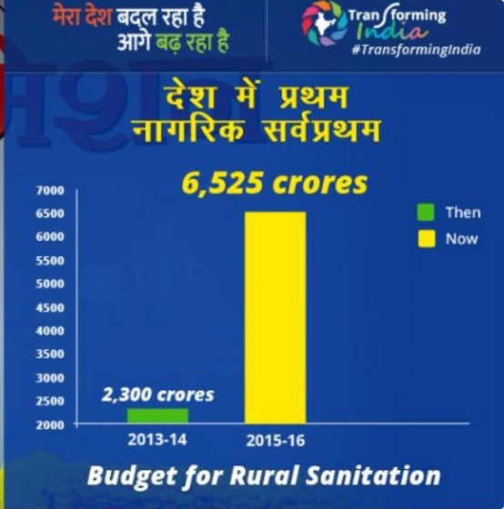



"Then" should be yellow; "now" should be green.



The numbers are wrong.



The y-axis doesn't start at zero.



Branding visualizations should be avoided at all costs.

**Correct**

This one is labeled as definitively wrong, while the other options are either not definitely, problematic, or unknown.

**1 / 1 point**

5.Question 5

This visualization has several issues with its design. Identify the only one of the following that is not an issue with this visualization.

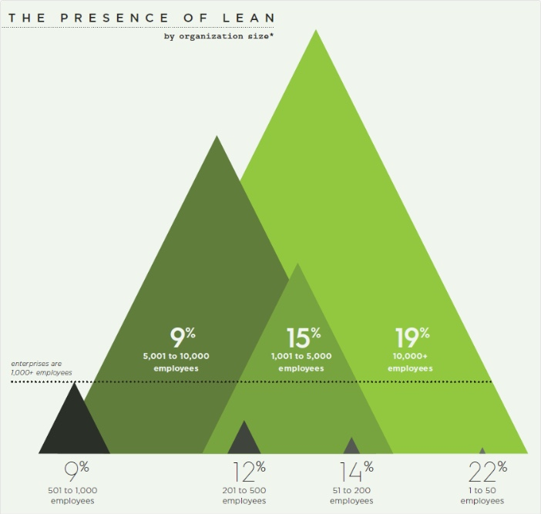



The bar heights do not match the percentages.



There is too much text.



It's very difficult to interpret.



The reference line is not clear.

**Incorrect**

Please revisit the lesson ***Ineffective Visuals and How to Improve Them***.

**Coursera suggests this material**

**BETA**

Was this material helpful?YesNo

* [Ineffective Visuals and How to Improve Them](https://www.coursera.org/learn/dataviz-design/lecture/x3x31)

Video • 7 min

**0 / 1 point**

6.Question 6

According to your readings, if you have a lot of categories in time series data, what is the best approach for your visualization from the following options:



A stream graph (a type of stacked area graph displaced around a central axis)



Stacked area graphs



Line graphs with totals above



Trellis plot

**Incorrect**

Please revisit the lesson ***Ineffective Visuals and How to Improve Them***.

**Coursera suggests this material**

**BETA**

Was this material helpful?YesNo

* [Ineffective Visuals and How to Improve Them](https://www.coursera.org/learn/dataviz-design/lecture/x3x31)

Video • 7 min

**0 / 1 point**

7.Question 7

True/False: It is more helpful to the reader to eliminate the axis altogether where appropriate and label individual data elements on the visualization itself.



False



True

**Correct**

Counterintuitive, but it's easier for people to read a visualization if it's labeled directly; and since it's labeled directly at least one of the axis can be eliminated.

**1 / 1 point**

8.Question 8

A 3D chart should be used only in the following circumstances:



Only when you need to compare values across categories.



Only when you need to plot three-dimensional data.



Whenever you want to add visual elements to your visualization that pop.



Whenever possible as long as you ensure that elements are well labeled.

**Correct**

But for the most part, you basically never want to use a 3D chart.

**1 / 1 point**

9.Question 9

Can you find the line with the average length in this set?

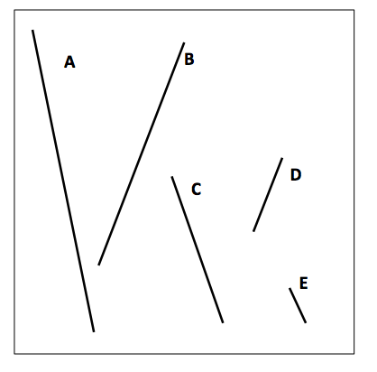

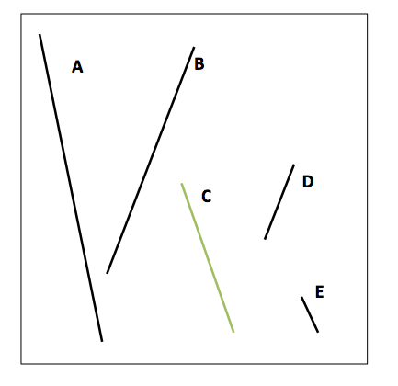

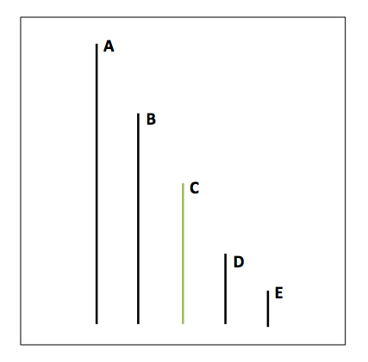



Line D



Line E



Line A



Line C



Line B

**Correct**

Line length is a “pop-out” effect (pre-attentive attribute) that the human brain can quickly process.

**1 / 1 point**

10.Question 10

When doing a visualization for a small committee that is looking at gender (male/female) comparisons, which of the chart choices is not recommended to use:



Pie chart



Bar graph



Cross-tabulation or table



Radar chart

**Correct**

Radar charts are even worse than pie charts. They are really difficult to interpret and there are many other options that are better to use before you should even consider a radar chart.

When doing a presentation for a large group of people, the best visualization to show differences between categories of data is one of the following:

BAR CHART

**1 / 1 point**

11.Question 11

A scatterplot is useful for showing ____________________.



Spatial information.



Data that are at different time periods.



Dimension on one axis and measures on the other axis.



Two different measures.

**Incorrect**

Please revisit the lesson ***Types of Visualizations***.

**Coursera suggests this material**

**BETA**

Was this material helpful?YesNo

* [Types of Visualizations](https://www.coursera.org/learn/dataviz-design/lecture/H9vJl)

Video • 5 min

**0 / 1 point**

12.Question 12

Pick the one time that you should not use a table.



Always avoid tables bigger than 2 x 2



When you are presenting to a large, live meeting.



At a committee meeting where people can spend time focusing on the visual.



On a website which people will access on their own time.

**Correct**

Tables are great, but it does make it hard for people to concentrate on both your talking and understanding the table. So try to avoid it.

**1 / 1 point**

13.Question 13

Humans have developed perceptual and cognitive capabilities that initially tend to favor ___________________?



Speed



Accuracy



Precision and completeness

**Incorrect**

Please revisit the lesson***The Human Brain and Data Visualization.***

**Coursera suggests this material**

**BETA**

Was this material helpful?YesNo

* [The Human Brain and Data Visualization](https://www.coursera.org/learn/dataviz-design/lecture/X9lVx)

Video • 5 min

**0 / 1 point**

14.Question 14

True/False: Data in a visualization must never be sorted based on the importance of the category of the data.



False



True

**Correct**

It's actually the best way to sort the data.

**1 / 1 point**

15.Question 15

Suppose you have a bar graph that has values of 4 and 5. If you start the axis at 0 and increment by 1, then the visual increase between the bars showing 5 and 4 is 25%. See example A:

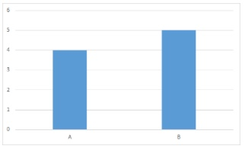

What would the visual increase be between the bars representing 4 and 5 if you started the axis at 3 and incremented by one? See example B:

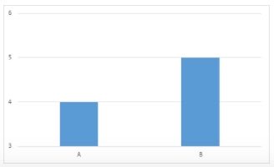



12.5%



60%



125%



100%

**Incorrect**

Please revisit the lesson ***Practicing Good Ethics in Data Visualizations***.

**Coursera suggests this material**

**BETA**

Was this material helpful?YesNo

* [Practicing Good Ethics in Data Visualization](https://www.coursera.org/learn/dataviz-design/lecture/YqHHo)

Video • 9 min

**0 / 1 point**

16.Question 16

Which most closely describes the process of visual encoding?



Transcending



Translation



Transposition

**Incorrect**

Please revisit the lesson***The Human Brain and Data Visualization.***

**Coursera suggests this material**

**BETA**

Was this material helpful?YesNo

* [The Human Brain and Data Visualization](https://www.coursera.org/learn/dataviz-design/lecture/X9lVx)

Video • 5 min

**0 / 1 point**

17.Question 17

System 2 refers to which type of thinking and responding?



Fast, intuitive, and emotional



Slow, deliberate, and logical



Moderate, methodical, and quantitative

**Correct**

System 2 is the realm of cognitive processing in which people make a focused effort to consider the meaning of what they are seeing. For a visualization to be effectively interpreted, System 1 and System 2, must work together to identify and accurately interpret meaningful patterns.

System 1 refers to which type of thinking and responding?

Moderate, methodical, and quantitative

Slow, deliberate, and logical

**1 / 1 point**

18.Question 18

If you had to figure out the sum of all line lengths, that would involve?



Only System 1



Systems 1 and 2



Only System 2

**Incorrect**

Please revisit the lesson***Cognitive vs Perceptual Design Distinction.***

**Coursera suggests this material**

**BETA**

Was this material helpful?YesNo

* [Cognitive vs Perceptual Design Distinction](https://www.coursera.org/learn/dataviz-design/lecture/gulX3)

Video • 4 min